EVALUATION OF BIOLOGICAL CHARACTERISTICS FOR EXTRACT FROM MUGWORT (ARTEMISIA VULGARIS L.)
(Đánh giá hoạt tính sinh học của cao chiết từ cây ngải cứu (Artemisia Vulgaris L.))

Le Nguyen Ky Giao^{1,2,3}_2110141_Biotechnology, Dinh Chan Phong^{1,2,3}_2352902_Biotechnology, Dinh Nguyen Chinh Nghia^{1,2,3}_2352804_Biotechnology, Pham Thuy Anh^{1,2,3}_2352064_Biotechnology, Lu Nhu Quynh^{1,2,3}_2110497_Biotechnology, Huynh Thu^{1,,3}, Tran Truc Thanh^{1,3,*}
¹ Faculty of Chemical Engineering, Ho Chi Minh City University of Technology (HCMUT), 268 Ly Thuong Kiet Street, District 10, Ho Chi Minh City, Vietnam
² Office for International Study Programs, Ho Chi Minh City University of Technology (HCMUT), 268 Ly Thuong Kiet Street, District 10, Ho Chi Minh City, Vietnam
³ Vietnam National University Ho Chi Minh City, Linh Trung Ward, Thu Duc District, Ho Chi Minh City, Vietnam
* Corresponding author: ttructhanh@hcmut.edu.vn

Abstract

Artemisia vulgaris L. (mugwort), a widely distributed herb native to temperate regions and cultivated extensively in Vietnam, contains diverse bioactive compounds such as polyphenols and flavonoids. Further investigation is needed to compare the bioactivities of individual constituents with the whole extract and to explore their practical applications. The mugwort extract was obtained using Soxhlet extraction with a raw material to methanol ratio of 1 : 50 over a period of 6 hours, yielding an extraction efficiency of 10.3 ± 0.84 %. Following extraction, the biological activities of the extract were assessed. Antioxidant capacity was measured using the DPPH radical scavenging method, while anti-inflammatory activity was evaluated through the inhibition of protein denaturation. Antibacterial activity was tested specifically against Staphylococcus aureus and Propionibacterium acnes using the agar well diffusion method. The results showed that the extract contained polyphenols (0.072 ± 0.011 mg/g_{DW}) and flavonoids (0.45 ± 0.07 mg/g_{DW}), and demonstrated notable antioxidant activity (7.83 ± 0.07 µg/mL) and anti-inflammatory effects (IC₅₀ = 0.70 mg/mL). However, at a concentration of 100 mg/mL, the extract did not exhibit significant antimicrobial activity against the tested microorganisms.
Keywords: Artemisia vulgaris L., mugwort, rutin, flavonoid, anti-inflammatory, antioxidant, bioactivity

1. Introduction
Mugwort (Artemisia vulgaris L.), a member of the Asteraceae family, is a perennial herb widely distributed across temperate regions of the world, including Europe and Africa, and is particularly easy to cultivate in Vietnam. It has long been used in both traditional Eastern and Western medicine for its beneficial effects, such as lowering blood lipid levels, protecting the liver, relieving pain, and reducing inflammation.
Scientific studies have revealed that mugwort leaves are rich in a variety of bioactive compounds, including flavonoids (such as rutin, quercetin, and luteolin), polyphenols, coumarin derivatives, sesquiterpene lactones, and essential oils. These constituents are known for their diverse biological activities, including antioxidant, antibacterial, anti-inflammatory, and antifungal properties [1, 2].
However, in Vietnam, research on the biological activities of Artemisia vulgaris L. leaf extracts remains limited—particularly in terms of quantifying phenolic and flavonoid contents and comprehensively evaluating their antioxidant, antibacterial, and anti-inflammatory effects. Therefore, investigating the extraction process and assessing the bioactivities of mugwort leaf extracts is essential to establish a scientific foundation for their application in skincare product development.

2. Methods and Implementation

2.1 Research Materials

Mugwort leaves (Artemisia vulgaris L.) used in this study were purchased from Thu Duc Market in Ho Chi Minh City, Vietnam.
A variety of chemicals and reagents were employed throughout the experiments. Standard rutin was sourced from Ark Pharm (USA). These included hydrochloric acid (HCl), methanol, and sodium hydroxide, all supplied by Chemsol (Vietnam). The antioxidant assay utilized 2,2-diphenyl-1-picrylhydrazyl (DPPH), and Folin–Ciocalteu obtained from Sigma-Aldrich (USA). Reagents included ascorbic acid, aluminum chloride, sodium nitrite, dimethyl sulfoxide (DMSO), and sodium carbonate, all purchased from XiLong (China). For microbiological testing, Mueller Hinton Agar and Brain Heart Infusion media were sourced from HIMEDIA. Gentamicin (HD Pharma) and clindamycin (Pfizer) were used as standard antibiotics in the antibacterial assays

2.2 Research Methodology

2.2.1 Extraction of crude extract from mugwort leaves (Artemisia vulgaris L.)
Fresh and intact mugwort leaves were collected and thoroughly washed before being dried at 60°C until their moisture content dropped below 15 %. The dried leaves were then homogenized and stored in a cool, dry place. The leaf powder was soaked in a 0.2 % HCl solution at a ratio of 1:10 (w/v) for 2 hours. The mixture was filtered and then subjected to Soxhlet extraction using methanol at a ratio of 1:50 (w/v) for 6 hours at 70°C. The resulting extract was concentrated using a rotary evaporator and further dried at 50–60°C to obtain the crude extract. The mass of the dried extract was recorded, and extraction efficiency was calculated using the formula:
% H = (Mass of extract / Mass of initial leaf powder) × 100 %.

2.2.2 Analysis of mugwort leaf extract
Total Flavonoid Content was determined using the aluminum chloride colorimetric method, which relies on the formation of a colored complex between flavonoids and Al³⁺. A rutin standard curve (0–0.3 mg/mL) was established. Absorbance was measured at 510 nm [4].
Total Polyphenol Content was quantified using the Folin–Ciocalteu method. A gallic acid standard curve (0.2 mg/mL) was used. The extract was dissolved in methanol and reacted with diluted Folin–Ciocalteu reagent and Na₂CO₃ (7.5 % v/v). After incubation in the dark, absorbance was measured at 760 nm [2, 5].

2.2.3 Biological activity evaluation of mugwort leaf extract (Artemisia vulgaris L.)
a. Evaluation of the antioxidant activity of Artemisia vulgaris extract.
Antioxidant Activity was assessed using the DPPH radical scavenging assay. The extract was diluted to various concentrations (1.5625–100 µg/mL) and mixed with DPPH solution. After 30 minutes of incubation in the dark, absorbance was measured at 517 nm [2, 3]. The scavenging activity was calculated using the formula:
S% = ((Ac − (As − Ab)) / Ac) × 100,
where Ac is the absorbance of the control, As is the sample absorbance, and Ab is the blank.

b. Evaluation of anti-inflammatory activity of Artemisia vulgaris L. extract.
Anti-inflammatory Activity was evaluated via the inhibition of protein denaturation using egg albumin. Extract and rutin were diluted to concentrations ranging from 0 to 1.25 mg/mL, while diclofenac sodium was used as a positive control (0–25 mg/mL). Samples were incubated with egg albumin at 37°C, then heated at 70°C. After cooling, absorbance was measured at 660 nm [6].

c. Antibacterial Activity was tested using two methods:
Agar Well Diffusion: Bacterial cultures of Staphylococcus aureus and Propionibacterium acnes were prepared and spread on agar plates. Wells were filled with 50 µL of extract (100 mg/mL), rutin, DMSO (negative control), and gentamicin (positive control). Plates were incubated at 37°C for 24 hours, and inhibition zones were measured in millimeters.
Minimum Inhibitory Concentration (MIC): The extract was diluted in DMSO and tested in a 96-well plate with concentrations ranging from 0.25 to 16 mg/mL. Resazurin (0.015%) was added after incubation to assess bacterial viability. MIC was determined as the lowest concentration that prevented color change from blue to pink. The same procedure was applied to P. acnes, using BHI medium and clindamycin as the control.

3. Results and Discussion

3.1 Artemisia vulgaris L. extract
The extract obtained from mugwort leaves (Artemisia vulgaris L.) exhibits a dark brownish-yellow color. During the extraction process, methanol serves as an effective solvent, capable of dissolving these bioactive compounds as well as the natural pigments present in the plant material. The resulting color reflects the concentration and composition of these phytochemicals in the extract.

Table 1. Physicochemical Characteristics of Mugwort (Artemisia vulgaris L.) Extract
Parameter | Value
Extraction yield (%) | 10.3 ± 0.84
Flavonoid content (mg/g_{DW}) | 0.452 ± 0.07
Polyphenol content (mg/g_{DW}) | 0.072 ± 0.01

The mugwort leaf extract yielded 10.3 ± 0.84 %, with a notably higher concentration of flavonoids (0.45 ± 0.07 mg/g_{DW}) compared to polyphenols (0.072 ± 0.01 mg/g_{DW}). This suggests that mugwort is a flavonoid-rich medicinal herb, making it a promising source for flavonoid extraction. Among these compounds, rutin—a key flavonoid present in mugwort—has been widely recognized for its diverse biological activities, including anticonvulsant, hypotensive, hepatoprotective, neuroprotective, antioxidant, anti-inflammatory, and antibacterial effects.
The presence of both polyphenols and flavonoids in mugwort extract indicates its potential for significant biological activities, particularly antioxidant, anti-inflammatory, and antibacterial effects. Previous studies support this potential: Temrar and El-Tantawy (2008) demonstrated the antioxidant activity of flavonoids in mugwort, confirming its role as a natural antioxidant [7]. Abiri et al. further highlighted mugwort’s anti-inflammatory, antioxidant, and antimalarial properties, attributed to its rich composition of polyphenols, flavonoids, and coumarins [8]. Similarly, research by Pandey, Thapa, and Upreti (2017) reported strong antioxidant and antibacterial activities in Artemisia vulgaris, reinforcing its value as a bioactive plant source [9].

3.2 Antioxidant Activity
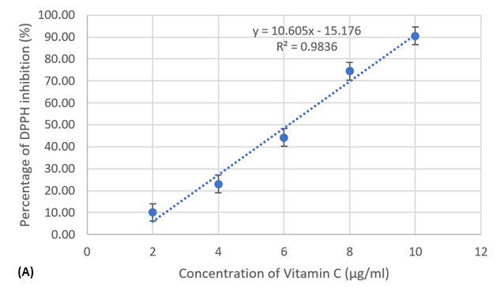

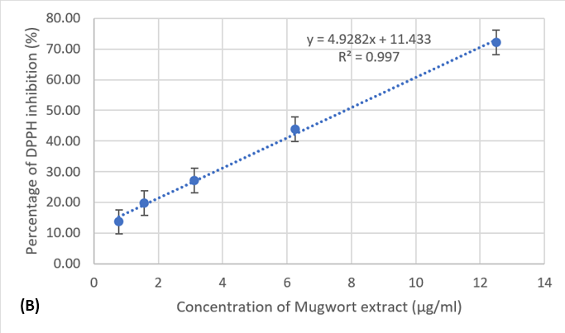
Figure 2. DPPH inhibition percentage of Ascorbic acid (A) and extract (B)

Table 2. IC₅₀ values of ascorbic acid and mugwort extract
 | Mugwort Extract | Vitamin C
IC₅₀ (mg/mL) | 7.83 ± 0.07 | 6.15

Based on the results presented in Table 2, the IC₅₀ value of the mugwort extract was approximately 1.27 times higher than that of vitamin C, indicating that its antioxidant capacity was correspondingly lower. However, when compared to findings from other studies, the methanol extract of Artemisia vulgaris L. demonstrates antioxidant activity comparable to the ethanol extract of Artemisia herba-alba, which ranged from 7.2 to 8.5 µg/mL in Alzandi’s 2021 study [10]. Notably, the mugwort extract exhibited stronger antioxidant activity than pure rutin, likely due to the presence of additional bioactive compounds such as flavonoids and polyphenols. These compounds contribute significantly to the overall antioxidant effect, suggesting a synergistic interaction that enhances the extract’s biological activity.

3.3 Anti-inflammatory Activity
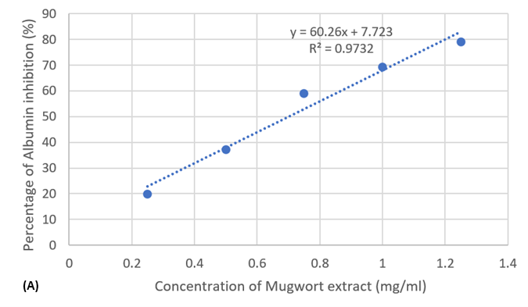
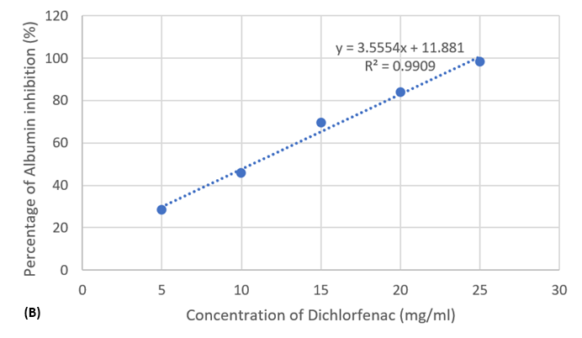
Figure 3. The Percentage Inhibition of Egg Albumin Denaturation by Diclofenac (A) and Mugwort Extract (B)
Table 3. IC₅₀ values evaluating the inhibitory capacity of extract and diclofenac on denaturation
 | Mugwort Extract | Diclofenac sodium
IC₅₀ (mg/mL) | 0.7 | 10.72

Based on the results presented in Table 3, the IC₅₀ value of diclofenac sodium was approximately 15.28 times higher than that of the mugwort extract, indicating that the mugwort extract possesses significantly greater anti-inflammatory activity. This potent effect was attributed to the presence of various bioactive compounds such as quercetin, luteolin, artemisinin, and polyphenols, all of which are known for their strong anti-inflammatory properties. These compounds exert their effects by stabilizing proteins, inhibiting key inflammatory enzymes like COX and LOX, and modulating inflammatory signaling pathways such as NF-κB (Sharma et al., 2020) [11].
Supporting evidence from other studies further reinforces these findings. For instance, research by Kim et al. (2023) [12] demonstrated that mugwort extract could suppress inflammatory markers including TNF-α, IL-6, and nitric oxide (NO), while enhancing the expression of antioxidant enzymes such as superoxide dismutase (SOD) and catalase (CAT). This dual action helps mitigate oxidative stress associated with inflammation. The IC₅₀ results of the methanol extract of Artemisia vulgaris not only confirm its superior in vitro anti-inflammatory efficacy but also corroborate previous findings, underscoring its potential for development into herbal-based anti-inflammatory therapeutics
3.4 Antibacterial Activity

3.4.1 Agar Diffusion Method
The results indicated that the mugwort extract, at a concentration of 100 mg/mL, exhibits minimal antibacterial activity against S. aureus and C. acnes. This was evidenced by the very small diameter of the inhibition zones observed in the agar well diffusion assay, suggesting that the extract was not significantly effective against these bacterial strains at the tested concentration
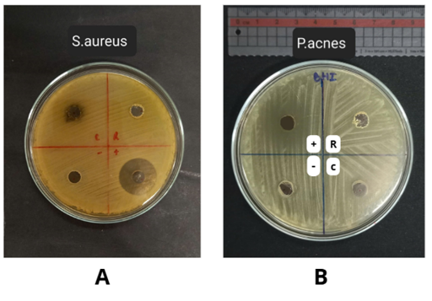
Figure 4. Bacterial inhibition zone of S. aureus and P. acnes
(A) Inhibition zone of S. aureus by (C) Extract, (R) - Rutin, (+) Gentamicin, (-) DMSO
(B) Inhibition zone of C. acnes by (C) Extract, (R) - Rutin, (+) Clindamycin, (-) DMSO

Table 4. Diameter of bacterial inhibition zones for the obtained mugwort extract and commercial rutin
Strain | Size of the inhibition zone (mm)
 | Gentamicin  (40 mg/mL) | DMSO | Standard Rutin  (40 mg/mL) | Extract  (100 mg/mL)
S. aureus | 23.2 ± 0.1 | - | - | 9.1 ± 0.2
Strain | Clindamycin  (50 mg/mL) | DMSO | Standard Rutin  (40 mg/mL) | Extract  (100 mg/mL)
P. acnes | 25.2 | - | - | 10.0

* (-): No inhibition zone appeared
** Results are the mean diameter of the inhibition zone (mm) ± standard deviation (SD).

3.4.2 Microdilution Method
Following the assessment of the antibacterial activity of the rutin-containing mugwort extract using the agar disc diffusion method, the Minimum Inhibitory Concentration (MIC) of the extract was assessed across a concentration range of 1, 2, 4, 8, and 16 mg/mL. The results were illustrated in Figure 5.
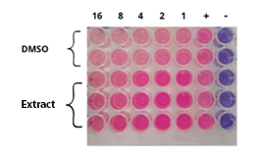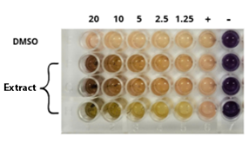
Figure 5. MIC results for S. aureus (A) and P. acnes (B) after staining with 0.015% resazurin.

After 24 hours of incubation, 0.015 % resazurin dye was added to each well to determine bacterial viability. Wells treated with mugwort extract showed pink coloration across all tested concentrations (1 to 16 mg/mL), indicating the presence of bacterial growth. These results suggested that the mugwort extract did not inhibit S. aureus at any of the tested concentrations. Similarly, for Propionibacterium acnes, bacterial growth was observed across the concentration range of 1.25 to 20 mg/mL, indicating a lack of sensitivity to the extract.

4. Conclusions
The extract obtained from Artemisia vulgaris L. leaves using Soxhlet extraction with methanol yielded an extraction efficiency of 10.3 ± 0.84 %. Quantitative analysis revealed that the extract contained 0.45 ± 0.07 mg/g DW of flavonoids and 0.072 ± 0.01 mg/g DW of polyphenols.
The extract demonstrated a strong DPPH radical scavenging ability, with an IC₅₀ value of 7.83 ± 0.07 µg/mL, which was relatively close to that of vitamin C (IC₅₀ = 6.15 µg/mL), indicating notable antioxidant potential. The extract exhibited a significantly stronger effect than the reference drug diclofenac sodium (IC₅₀ = 10.72 mg/mL), with an IC₅₀ of 0.7 mg/mL, highlighting its potent anti-inflammatory properties. At the tested concentration of 100 mg/mL, the extract did not show antibacterial activity against S. aureus or P. acnes, suggesting limited efficacy in antimicrobial applications under these conditions. In conclusion, the extract of Artemisia vulgaris L. exhibited potent antioxidant and anti-inflammatory activities, underscoring its potential for development as a natural ingredient in skincare formulations.

Acknowledgement: This research was funded by the Office for International Study Programs (OISP), Ho Chi Minh City University of Technology (HCMUT), VNUHCM under grant number SVOISP-2024-KTHH-74. We acknowledge Ho Chi Minh City University of Technology (HCMUT), VNU-HCM for supporting this study.

Reference
[1] S. J. Lee, H. Y. Chung, C. G. A. Maier, A. R. Wood, R. A. Dixon, and T. J. Mabry, "Estrogenic Flavonoids from Artemisia vulgaris L.," J. Agric. Food Chem., vol. 46, pp. 3325–3329, 1998.

[2] S. Khennouf, I. H. El-Haci, S. Amessis-Ouchemoukh, N. Ouchemoukh, A. Ramdani, and M. Ramdani, "Antioxidant and antibacterial activities of extracts from Artemisia herba alba Asso. leaves and some phenolic compounds," J. Med. Plants Res., vol. 4, no. 13, pp. 1273-1280, 2010.
[3] N. Saeed, M. R Khan and M. Shabbir., “Antioxidant activity, total phenolic and total flavonoid contents of whole plant extracts Torilis leptophylla L.,” BMC Complementary and Alternative Medicine, vol. 12, no. 1, p. 221, 2012.
[4] L. Fu, B. T. Xu, X. R. Xu, R. Y. Gan, Y. Zhang, and H. B. Li, “Antioxidant capacities and total phenolic contents of 62 fruits,” Food Chemistry, vol. 129, no. 2, pp. 345–350, 2011.
[5] C. Ogbiko, G. A. Ahuchaogu, and S. E. Obasi, “Total phenolic and flavonoid contents and antioxidant activities of some Nigerian medicinal plants,” Journal of Pharmaceutical Research International, vol. 19, no. 3, pp. 1–11, 2017.
[6] M. Shah, S. M. Patel, H. A. Patel, and S. B. Parmar, “Evaluation of antioxidant, anti-inflammatory, analgesic and antipyretic activities of the stem bark of Sapindus mukorossi,” BMC Complementary and Alternative Medicine, vol. 17, no. 1, p. 526, 2017.
[7] A. Temrar and W. El-Tantawy, "Characterization of antioxidant activity of extract from Artemisia vulgaris," Pakistan Journal of Pharmaceutical Sciences, vol. 21, no. 4, pp. 321–326, 2008.
[8] R. Abiri, A. L. M. Silva, L. S. S. de Mesquita, J. W. C. de Mesquita, N. Atabaki, E. B. de Almeida Jr., N. A. Shaharuddin, S. Malik, "Towards a better understanding of Artemisia vulgaris: Botany, phytochemistry, pharmacological and biotechnological potential," Food Research International, vol. 109, pp. 403–415, 2018.
[9] B. P. Pandey, R. Thapa, and A. Upreti, "Chemical composition, antioxidant and antibacteria activities of essential oil and methanol extract of Artemisia vulgaris and Gaultheria fragantissima collectes from Nepal," Asian Pac J Tropmed, vol. 10, no. 10, pp. 952–959, 2017.
[10] H. Alzandi, N. Zraoula, S. Belhattab, S. Seghier, A. Djebbar, L. Toumi, and S. Bouguerra, "Antioxidant and cytotoxic activities of Artemisia herba-alba essential oil and its major constituents," Journal of Ethnopharmacology, 2021.
[11] D. Sharma, R. Kaur, and M. Singh, "Anti-inflammatory potential of rutin through modulation of NF-κB signaling in LPS-activated macrophages," Journal of Pharmacy and Pharmacology, vol. 73, no. 1, pp. 110–118, 2020.
[12] S. H. Kim, S. Y. Lee, and H. Y. Choi, "Artemisia vulgaris extract attenuates inflammation and oxidative stress in vitro and in vivo," Journal of Medicinal Food, 2023.

